# Creating and Querying a View - High Scores

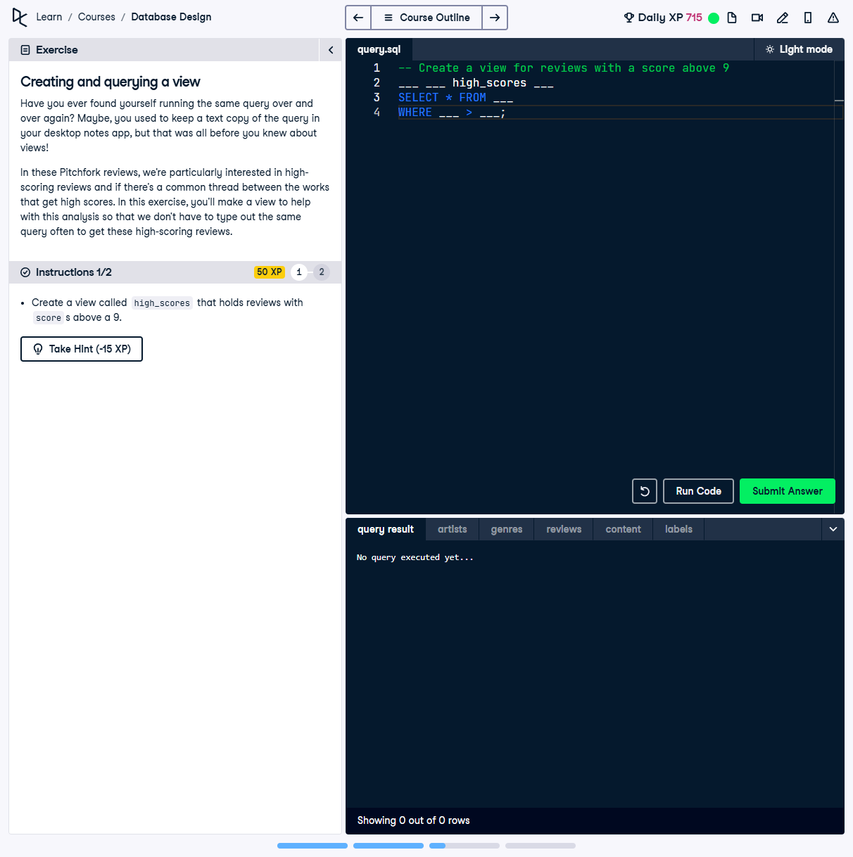

## Question

Create a view called `high_scores` that holds reviews with `score` values above 9.0.

## ✅ Correct SQL Query

```sql  
-- Create a view for reviews with a score above 9  
CREATE VIEW high_scores AS  
SELECT * FROM REVIEWS  
WHERE score > 9;  
```

## Answer Explanation

🔹 The **CREATE VIEW** statement is used to store a frequently used query.  
  
🔹 The `high_scores` view filters the `REVIEWS` table **to only include reviews**  
 where the `score` is greater than `9`.  
  
🔹 This makes querying high-scoring reviews **much easier and reusable**, avoiding  
 the need to repeatedly write the same `WHERE` condition.